# Cachero, Joshua Bryan A.

**BSIT-4A**

**Narrative Report on Workshop on Website User Interface Designing**

**Introduction:**

The Workshop on Website User Interface Designing was conducted on September 4-5, 2023 at ESSU computer laboratory. The workshop provided participants with comprehensive knowledge and practical skills in designing user-friendly and visually appealing website interfaces. It was organized by Mr. Armil Garol and attended by the 4th year students from BSIT & BSCS.

**Workshop Highlights**

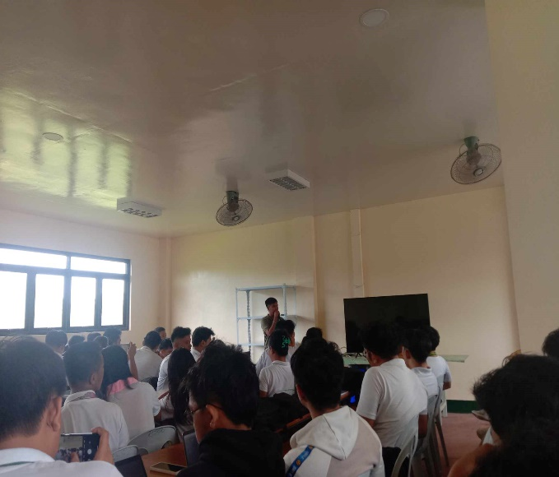**Session 1:** Self-Introduction of the speaker Sir. Armil Garol, he talked about how he got his previous jobs, his hardships and how he acquired the knowledge and skills to UI Designing, the workshop proceeded with a comprehensive introduction to User Interface (UI) design, where participants learned about the significance of user-centric design, the role of UI in websites, and the principles that guide effective UI design

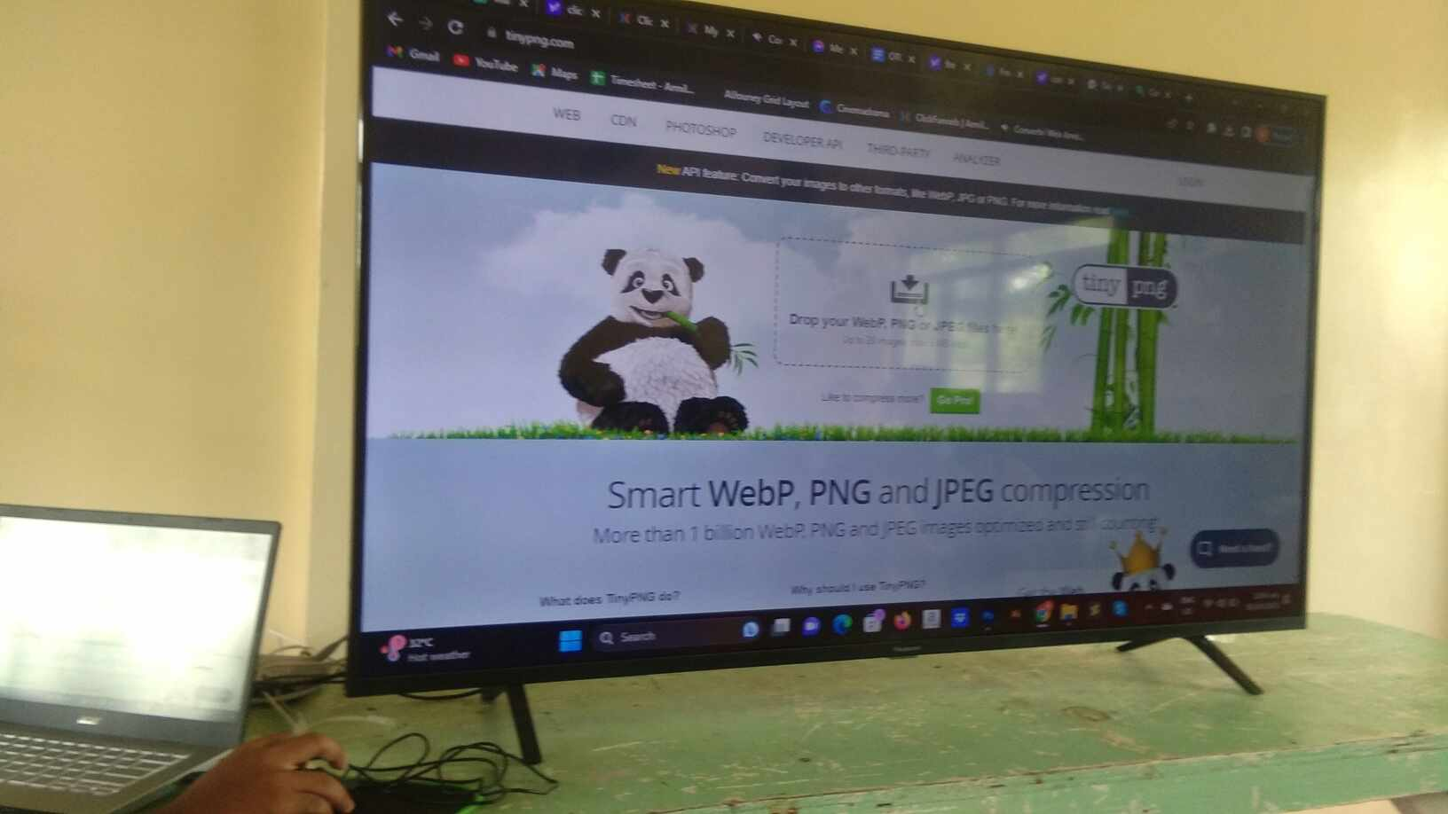

**Session 2:** Design Tools and Software, this session delved into the essential tools and software used in UI design, including Adobe photoshop and an AI tool. Participants received hands-on experience with these tools to create mockups.

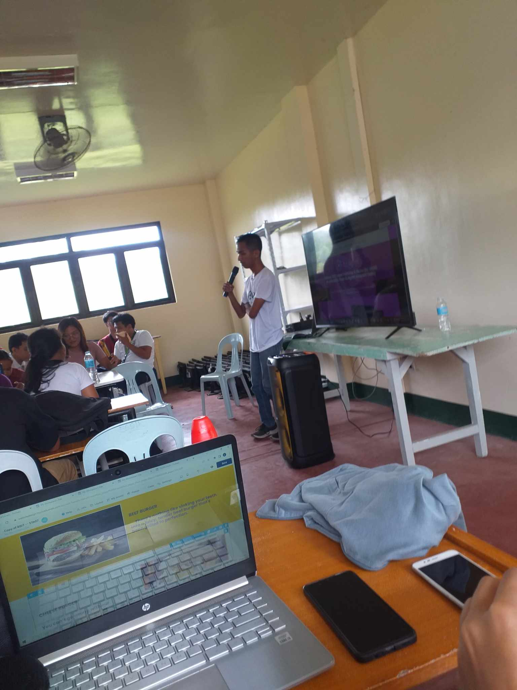

**Session 3:** Wireframing and Prototyping, we students were guided through the process of wireframing and prototyping, where they learned to translate ideas into visual representations. Practical exercises were held to help reinforce these concepts.

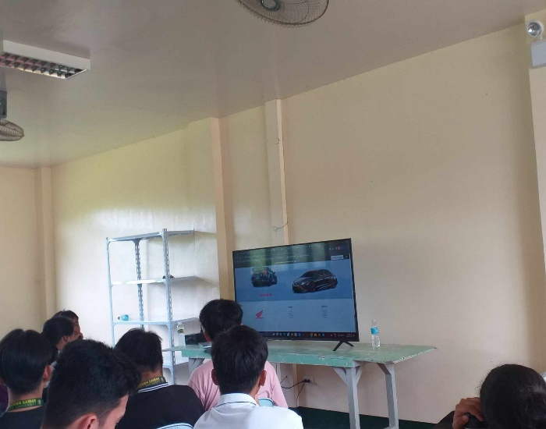

**Session 4:** Final Projects and Presentation To culminate the workshop, we worked on our designated UI design projects, applying the knowledge gained throughout the workshop. Then presented the projects, then received constructive feedback.

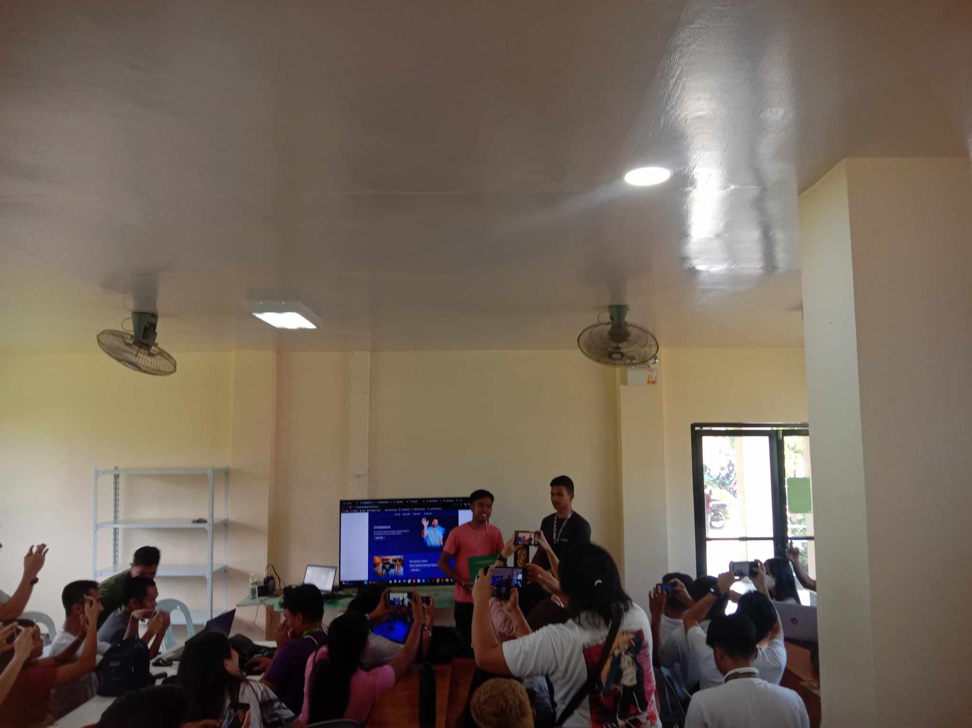

**Session 5:** End of workshop, after two not very short but knowledgeable days the workshop has ended with everyone gaining knowledge and skills that might be used as their advantage for their future career paths.

**Reflection**

As the workshop drew to a close, I couldn't help but reflect on the immense value it had provided. Two intensive days had transformed my understanding of UI design, from the theoretical principles to practical application. The knowledge and skills acquired during this workshop are undoubtedly assets that I can leverage in my future career. Mr. Garol's guidance and the hands-on approach of the workshop made this learning experience both informative and enjoyable.

In conclusion, the Workshop on Website User Interface Designing was an enriching journey that expanded my knowledge and triggered my curiosity for UI design. I am grateful for the opportunity to have participated in this workshop, and I look forward to applying these newfound skills and insights in my future endeavors.